**CHANGES TO ORGANIZER DASHBOARD -**

1. There should be the list of all categories to choose from so they can choose.

List -

* Day & Night Parties
* Music & Concerts
* Business & Networking
* Sports & Fitness
* Food & Drink
* Arts & Theater
* Festivals & Holidays
* Bollywood
* Travel & Outdoor
* Education & Careers
* Expos & Exhibitions
* Conferences & Seminars
* Fashion & Beauty
* Film & Media
* Meet & Greet
* Technology & Innovation
* Gaming & eSports
* Religious & Spiritual
* Pets & Animals
* Literary & Books
* Cultural Fests
* Home & Garden
* Hobbies & Interests
* Health & Wellness
* Charity & Causes

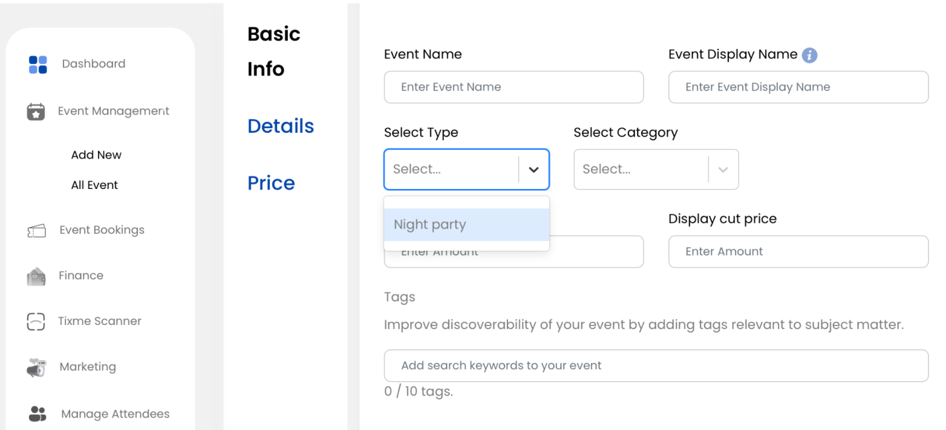

1. This should be an automated system for the organizer to choose the location with the help of google maps api -



1. They need to be able to choose the currency they want -

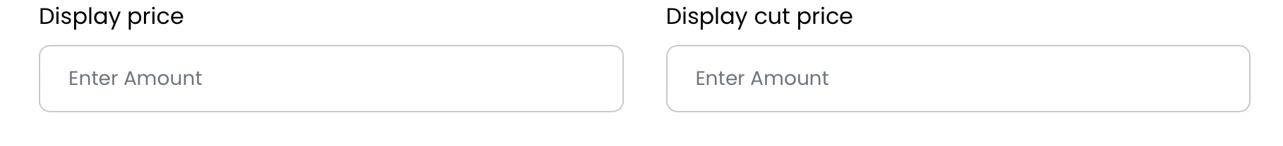

1. There needs to be a time zone they can set their event time in -

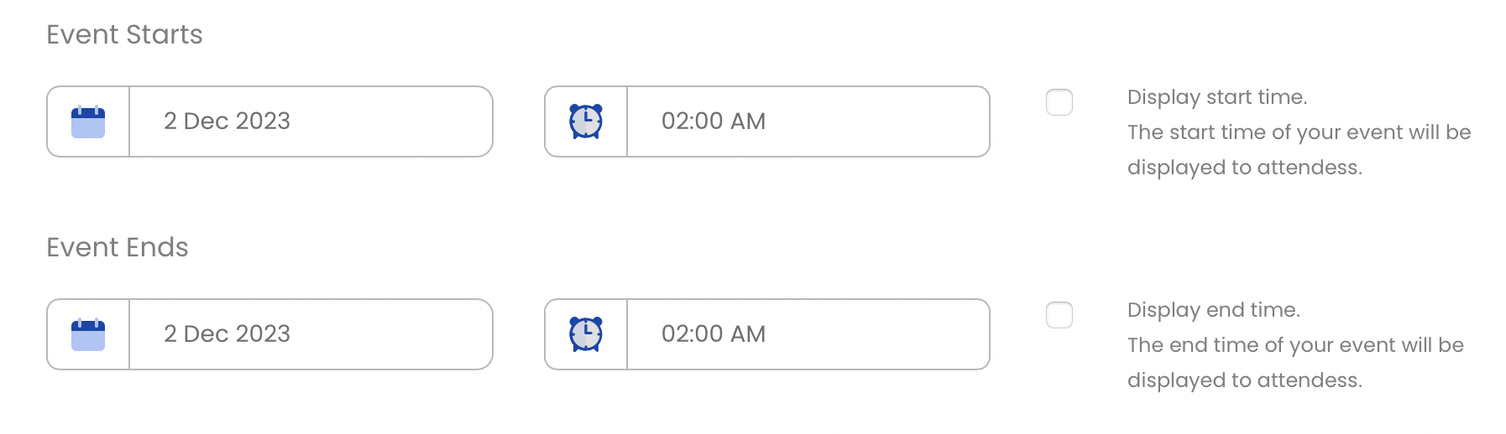

1. These buttons are not working for me -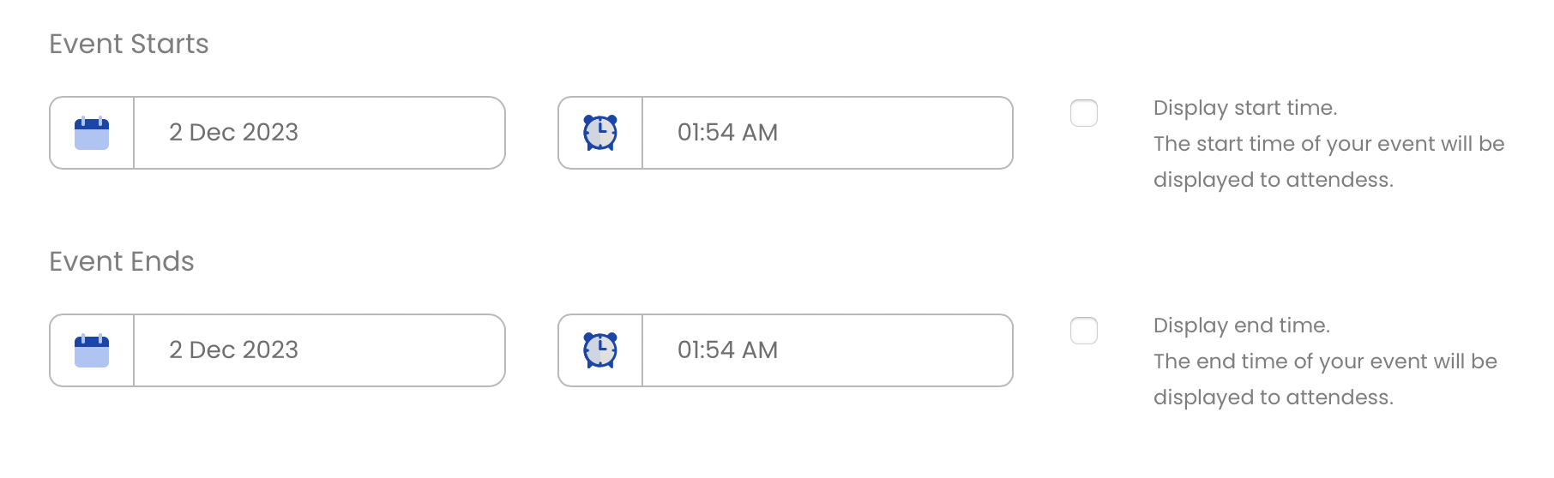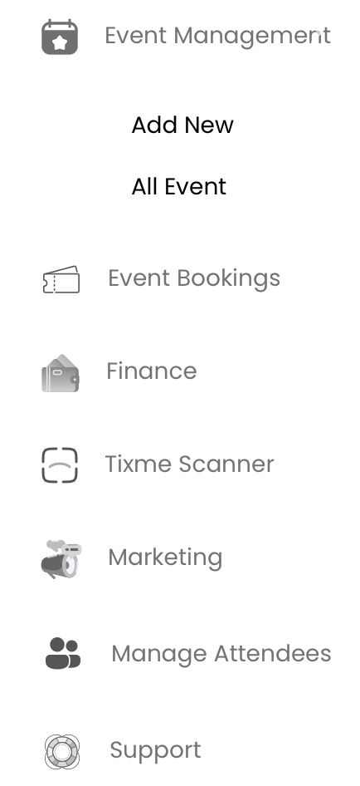
2. There needs to be a section where the organizer sees all their details of the customers who are attending the event.